Name: Class:

ST ANDREW’S JUNIOR COLLEGE

JC2 Preliminary Examinations
CHEMISTRY  Higher 2  Paper 2 Structured Questions | 9647/02  16 Sept 2010  2 hours
Additional Materials: Data Booklet
Instructions to candidates:
Answer all questions.
A Data Booklet is provided.
Write your answers in the space provided on the question paper. The number of marks is given in brackets [ ] at the end of each question or part question.

For Examiner’s Use
1
2
3
4
5
6
7
8
Total | /72

This document consists of 15 printed pages including this page.

Planning (P)

1 | Acid A is HO₂C(CH₂)₄CH(Cl)CO₂H (M_{r}: 194.5)  Acid B is HO₂C(CH₂)₃COCH₂CO₂H (M_{r}: 174)  Acid C is HO₂C(CH₂)₂CH=CHCH₂CO₂H (M_{r}: 158)
 | a) | FA 1 is a solution containing one of the acids A – C with concentration 10.0 g per dm³.  Given solid potassium hydroxide pellets and all standard laboratory apparatus, design a titrimetric experiment to determine which acid is present in FA 1.  In your plan, describe clearly the steps you would carry out and justify the amounts of chemicals you would use.  Show clearly how you would determine the identity of the acid.  [8]
 | b) | FA 2 is a solution containing 1 mol dm⁻³ of either acid C or CH₃(CH₂)₃COOH.  In an attempt to identify the acid present in FA 2, a student decided to mix different volumes of FA 2 and aqueous KOH in two separate experiments. The temperature rise for each experiment was measured.
 |  | i) | Given the concentration of aqueous KOH used in the experiments is 1 mol dm⁻³, complete the following table.  [2]
  Experiment | Vol of KOH / cm³ | Vol of FA 2 / cm³ | Temperature rise / ºC
  1 |  |  | T₁
  2 |  |  | T₂
 |  | ii) | Explain how the student can make use of the data collected in bi) to identify the acid in FA 2.  ………………………………………………………………………………………................  ………………………………………………………………………………………................  ………………………………………………………………………………………................  [2]  Total: 12 marks
 |  |  | [Turn over
2 | a) | A 5.00 g sample of galinstan, a tin-containing ore, was dissolved in 100.00 cm³ of excess acid. The solution was found to contain tin(II) ions.  On addition of KNO₃, all the tin(II) ions were converted to tin(IV) ions. 25.0 cm³ of the resulting tin(IV) solution was titrated with 0.120 mol dm⁻³ thiosulfate solution. The titre volume was found to be 23.00 cm³.
 |  | i) | Given that NO₃⁻ was reduced to NO₂⁻ , write the half equation for the reduction reaction.  ………………………………………………………………………………………................  [1]
 |  | ii) | Calculate how many moles of tin(II) ions were present in the 100.0 cm³ solution and hence the percentage by mass of tin in the galinstan sample.  [3]
 | b) | i) | Tin compounds are mostly white whereas transition metal compounds are usually coloured. Explain the statement clearly.  ………………………………………………………………………………………................  ………………………………………………………………………………………................  ………………………………………………………………………………………................  ………………………………………………………………………………………................  [3]
2 | b) | ii) | Using relevant data from the Data Booklet, explain how Co³⁺ can act as a homogenous catalyst in the following reaction.  S₂O₈²⁻(aq) + 2I⁻(aq) → 2SO₄²⁻(aq) + I₂(aq)  ………………………………………………………………………………………................  ………………………………………………………………………………………................  ………………………………………………………………………………………................  ………………………………………………………………………………………................  [3]  Total: 10 marks
3 | The table below shows some thermochemical data:
   | ∆H^{θ}/ kJ mol⁻¹
  Ca(s) + aq → Ca²⁺(aq) + 2e | +347
  Ca(s) + S(s) + 2O₂(g) → CaSO₄(s) | -1435
  Ca²⁺(g) + aq → Ca²⁺(aq) | -1577
  S(s) +2O₂(g) +aq + 2e → SO₄²⁻(aq) | -907
  N₂(g) + O₂(g) + aq + e → NO₃⁻(aq) | -206
 | a) | Use the data in the table above to construct an energy cycle to calculate the standard enthalpy change of the following reaction:  Ca(NO₃)₂(aq) + H₂SO₄(aq) → CaSO₄(s) + 2HNO₃(aq)  [3]  [Turn over
3 | b) | With reference to the Data booklet and the information given above, calculate the enthalpy change of atomisation of calcium.  [2]  Total: 5 marks
4 | Nitrogen and oxygen can react together as shown  N₂(g) + O₂(g) 2NO(g) ∆H = +180 kJ mol⁻¹
 | a) | Suggest a reason for the highly endothermic ∆H value for the reaction.  ………………………………………………………………………………………………………...  ………………………………………………………………………………………………………...  [1]
 | b) | Using Le Chatelier’s principle, account for the high composition of gaseous NO in car engines.  ………………………………………………………………………………………………………...  ………………………………………………………………………………………………………...  ………………………………………………………………………………………………………..  [2]
4 | c) | NO can react further with O₂ to give NO₂ according to the following equation.  2NO(g) + O₂(g) 2NO₂(g)  The following data shows the number of moles of each gaseous molecule at equilibrium in 2 vessels of different capacities at constant temperature.  Calculate the value of K_{c} and hence the value of x.  [4]  Total: 7 marks
   | 200 cm³ vessel | x cm³ vessel
  Moles of NO(g) | 0.42 | 1.56
  Moles of O₂(g) | 0.52 | 5.78
  Moles of NO₂(g) | 0.24 | 1.88

5 | 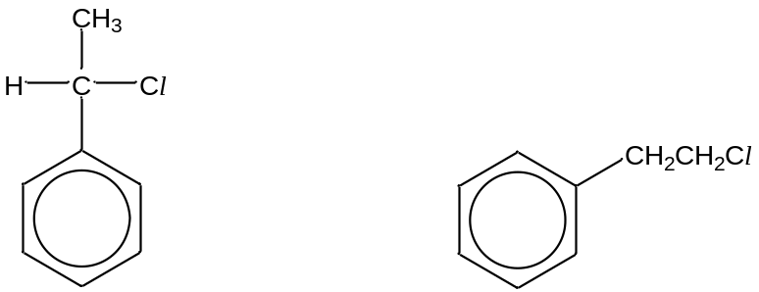  Isomer A Isomer B  In an experiment, two isomers of C₈H₉Cl shown above were reacted separately with aqueous sodium hydroxide.
 |  | [Turn over
5 | The rate of reaction for each isomer was measured and shown in the graphs below.
 | Rate |  | Rate
Isomer B
Isomer B

Isomer A
Isomer A

[NaOH]
[C₈H₉Cl]

 | a) |  | Deduce the rate equation for this reaction for each of the isomers.
Isomer A: Rate = ……………………………………
Isomer B: Rate = …………………………………… [2]
 | b) |  | In another experiment, isomer A and compound C were reacted separately with sodium hydroxide and the rates of reaction were measured and shown in the graph below.
Rate
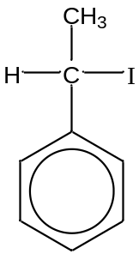
Compound C

Graph 1
Graph 2

[C₈H₉X]

 |  |  | i) | Identify which graphs belong to each compound.
Compound A: Graph ………
Compound C: Graph ………

 |  |  | ii) | Justify your answers in (b)(i).  …………………………………………………………………………………………………  …………………………………………………………………………………………………  …………………………………………………………………………………………………
[3]
Total: 5 marks

6 | a) | The standard electrode potential of NO₃⁻/N₂O half cell is given below  2NO₃⁻ + 10H⁺ + 8e⁻ N₂O + 5H₂O Eº = +1.11V  V  N₂O(g) at 1 atm  Ag  Pt  [NO₃⁻(aq)]=[H⁺(aq)] [Ag⁺(aq)]= 1.0 mol dm⁻³  = 1.0 mol dm⁻³
 |  | i) | With reference to the Data booklet, write the equation for the reaction and calculate the Eº_{cell}.  Equation: ……………………………………………………………………………………...  Eº_{cell} = ………………………………………………………………………………………….  [2]
 |  | ii) | Indicate the direction of electron flow on the diagram above. [1]
 | b) | The K_{sp} of Ag₂Cr₂O₇ is 2.0 × 10⁻⁷ mol³ dm⁻⁹. Calculate the mass of Ag₂Cr₂O₇ precipitated if 0.02 moles of Na₂Cr₂O₇ is dissolved in 1 dm³ of a saturated solution of Ag₂Cr₂O₇ at this temperature.  [3]  [Turn over
6 | c) | Aqueous NH₃ can be used to distinguish AgCl and AgI. Explain with the aid of relevant equations.  ………………………………………………………………………………………………………..  ………………………………………………………………………………………………………..  ………………………………………………………………………………………........................  ………………………………………………………………………………………………………..  ………………………………………………………………………………………………………..  [2]  Total: 8 marks
7 | Antioxidants prevent or decrease the oxidation of other molecules by being oxidised themselves. In doing so, they inhibit other oxidation reactions in the body.
 | a) | Vitamin C is an essential nutrient for the well being of humans.  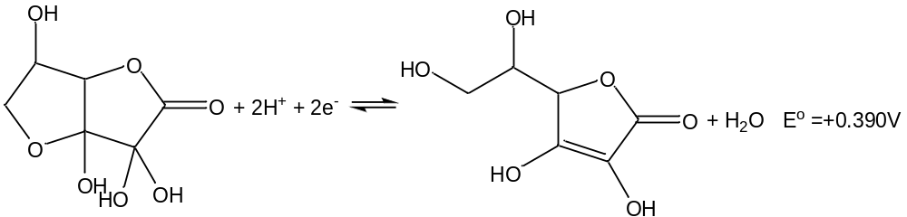  Vitamin C
 |  | i) | Cells are protected against oxidative stress in the body caused by various chemical reactions using antioxidant enzymes. In oxidative phosphorylation, active oxygen species such as hydrogen peroxide, H₂O₂, is produced. By referring to an appropriate H₂O₂ half equation in the Data Booklet and the above equation, explain why vitamin C can act as an antioxidant.  ………………………………………………………………………………………................  ………………………………………………………………………………………………….  ………………………………………………………………………………………………….  [2]
7 | a) | ii) | Vitamin C and phenol are both bulky molecules. Phenol is insoluble in water but Vitamin C is extremely soluble in water. Draw a diagram to explain why Vitamin C is water soluble.  [2]  [Turn over
7 | b) | Research has proven that polyphenols have substantial antioxidant activity. Polyphenols have more than 1 phenol group per molecule. An example of a polyphenol is chlorogenic acid.  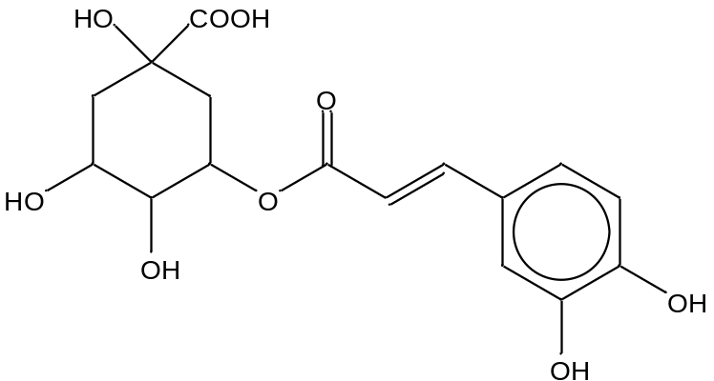  Chlorogenic acid
Chlorogenic acid is treated with the following reagents. Draw the structural formulae of all the organic products formed in the reactions.
Reagent | Structural formula of organic products
Solid Na₂CO₃
aq NaOH, heat
SOCl₂
aq Br₂
[6]
7 | c) | Another antioxidant commonly found in anti-acne cream is salicylic acid. It has chemical properties similar to acetylsalicylic acid commonly known as aspirin.  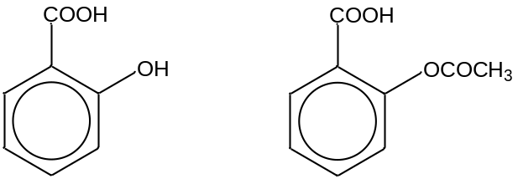  Salicylic acid Aspirin
 |  | i) | State the reagents and conditions to distinguish between salicylic acid and aspirin.  ………………………………………………………………………………………………….  [1]
 |  | ii) | State the reagents and conditions required to convert salicylic acid to aspirin.  …………………………………………………………………………………………………  [1]
 |  | iii) | Salicylic acid can be converted to Compound Y through an intermediate, Compound X.  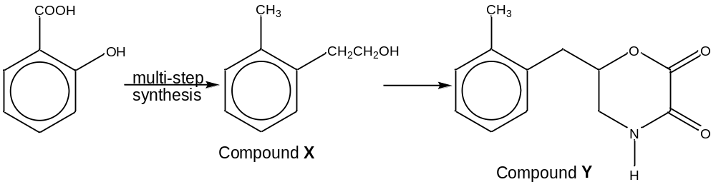  Suggest a synthesis to convert Compound X to Compound Y.  [4]  [Turn over
7 | c) | iv) | Explain how the acidity of aspirin will compare with the compound below.  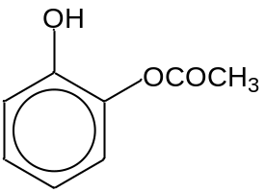  ………………………………………………………………………………………………………………………………………………………………………………………………………………………………………………………………………………………………………  [2]
 |  | v) | 4-hydroxybenzoic acid is a structural isomer of salicylic acid. State and explain whether salicylic acid or 4-hydroxybenzoic acid will have a higher boiling point.  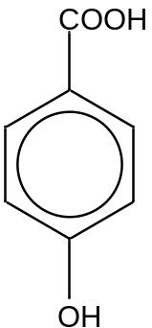 4-hydroxybenzoic acid  …………………………………………………………………………………………………  …………………………………………………………………………………………………  …………………………………………………………………………………………………  [2]  Total: 20 marks
8 | The diagram below shows the structure of a fragment from a protein found in a slice of meat. The only three amino acids present in the slice of meat are methionine(Met), phenylalanine(Phe) and histidine(His).  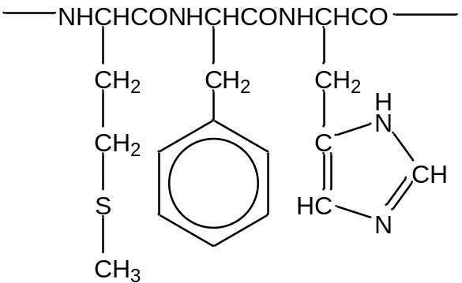  Met Phe His
 | a) | The structure of proteins can be disrupted causing proteins to form random coils of polypeptide chains.  Draw a labelled diagram to illustrate the types of interactions that could be involved in the maintenance of the tertiary structure of the protein fragment above.  [3]
 | b) | In the cooking preparation of the dish, the meat was first marinated with apple cider vinegar and grilled. With reference to the protein fragment above, explain what happens to the tertiary protein structure of the meat in the cooking preparation.  ………………………………………………………………………………………........................  ………………………………………………………………………………………………….…….  ………………………………………………………………………………………………….…….  ………………………………………………………………………………………........................  [2]  Total: 5 marks  ~~~~~END OF PAPER~~~~~

